Day 16
Selection Sort
- Create a array
- Keep the length of array declared
- Max not declared
  - Search for the largest number using the for loop
  - Use the element through the length -1
  - Find the index of greatest integer
  - Swap th e element index of greates integer with the
- Reiterate till all elements ate sorted using for loop

(a: array of integers, n: size of array)
For i from n-1 to 1
maxIdx = i
For j from 0 to i-1
If a[j] >= a[maxIdx]
maxIdx = j
Swap a[i] and a[maxIdx]
End For
End Procedure

Task 3: Wap to make sure your list is sorted using selection sort.
public class Day16_Task003 {
public static void main(String[] args) {
int[] a = {87,23,90,45,56,23,45,67};
System.out.println("Original array:");
for (int i : a) {
System.out.print(i + " ");
}
System.out.println();
//starting to sort
//87,23,90,45,56,23,45,(n[7]-1->1=)67
for (int i = a.length - 1; i >= 1; i--) {
int max = i;
//87,23,90,45,56,23,45,67 == i==6, j==5
for (int j = 0; j < i; j++) {
//if45>76
//if 23.................90>67
if (a[j] > a[max]) {
//2
max = j;
}
}
int temp = a[max];
//
a[max] = a[i];
a[i] = temp;
}
System.out.println("Sorted array:");
for (int i : a) {
System.out.print(i + " ");
}
}
}

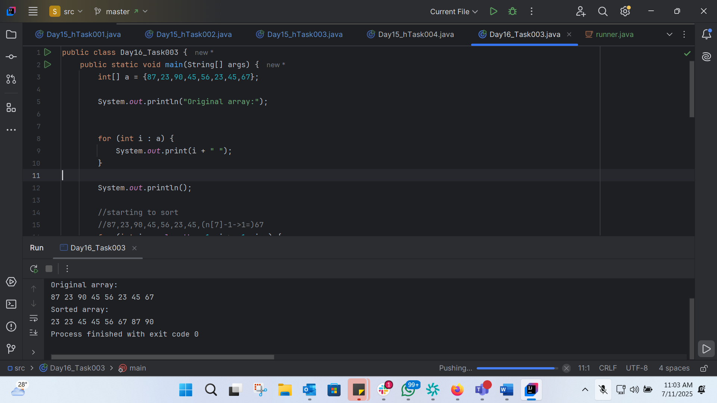
Task 4 Bubble sorting algorithem
- Start at the beginning of the array
- Compare the frst 2 elements if ther are in wrng order swap them
- Move to the next pair and do the same continue this till the end
- Now repeat the same till the end and then start from the beginning till the entire array is sorted
TASK 5 Psudo code for Bubble sorting
Arr: array
N=lenth of arr
for int i=0; i<=n-2;i++
for int j= 1; j<=n-1;j++
if arr[i]>arr[j]-> swap
arr[i]=arr[j]

Task 6 : Wap to make sure your list is sorted using Bubble sort.
public class Day16_Task006 {
public static void main(String[] args) {
int[] a = {5, 2, 8, 3, 1, 6, 4};
int n = a.length;
System.out.println("A array:");
for (int i : a) {
System.out.print(i + " ");
}
System.out.println();
//5, 2, 8, 3, 1, 6, [4]
for (int i = n - 1; i >= 1; i--) {
//5, {[2]}, 8, 3, 1, 6, 4
for (int j = 1; j <= i; j++) {
if (a[j - 1] > a[j]) {
//if 5>2
//temp= 2
//[j]=[[1]-1]=1
//taking next element
//void bubbleSort(int a[], int n) {
//for (int i = n-1; i >= 1; i--) {
//for (int j = 1; j <= i; j++) {
//
//Step 1:
//for (int j = 1; j <= i; j++) { Compare
//if (a[j-1] > a[j])
//swap(a[j], a[j-1]);
//
//}
//}
//}
int temp = a[j];
a[j] = a[j - 1];
a[j - 1] = temp;
}
}
}
System.out.println("after sorting:");
for (int i : a) {
System.out.print(i + " ");
}
}
}

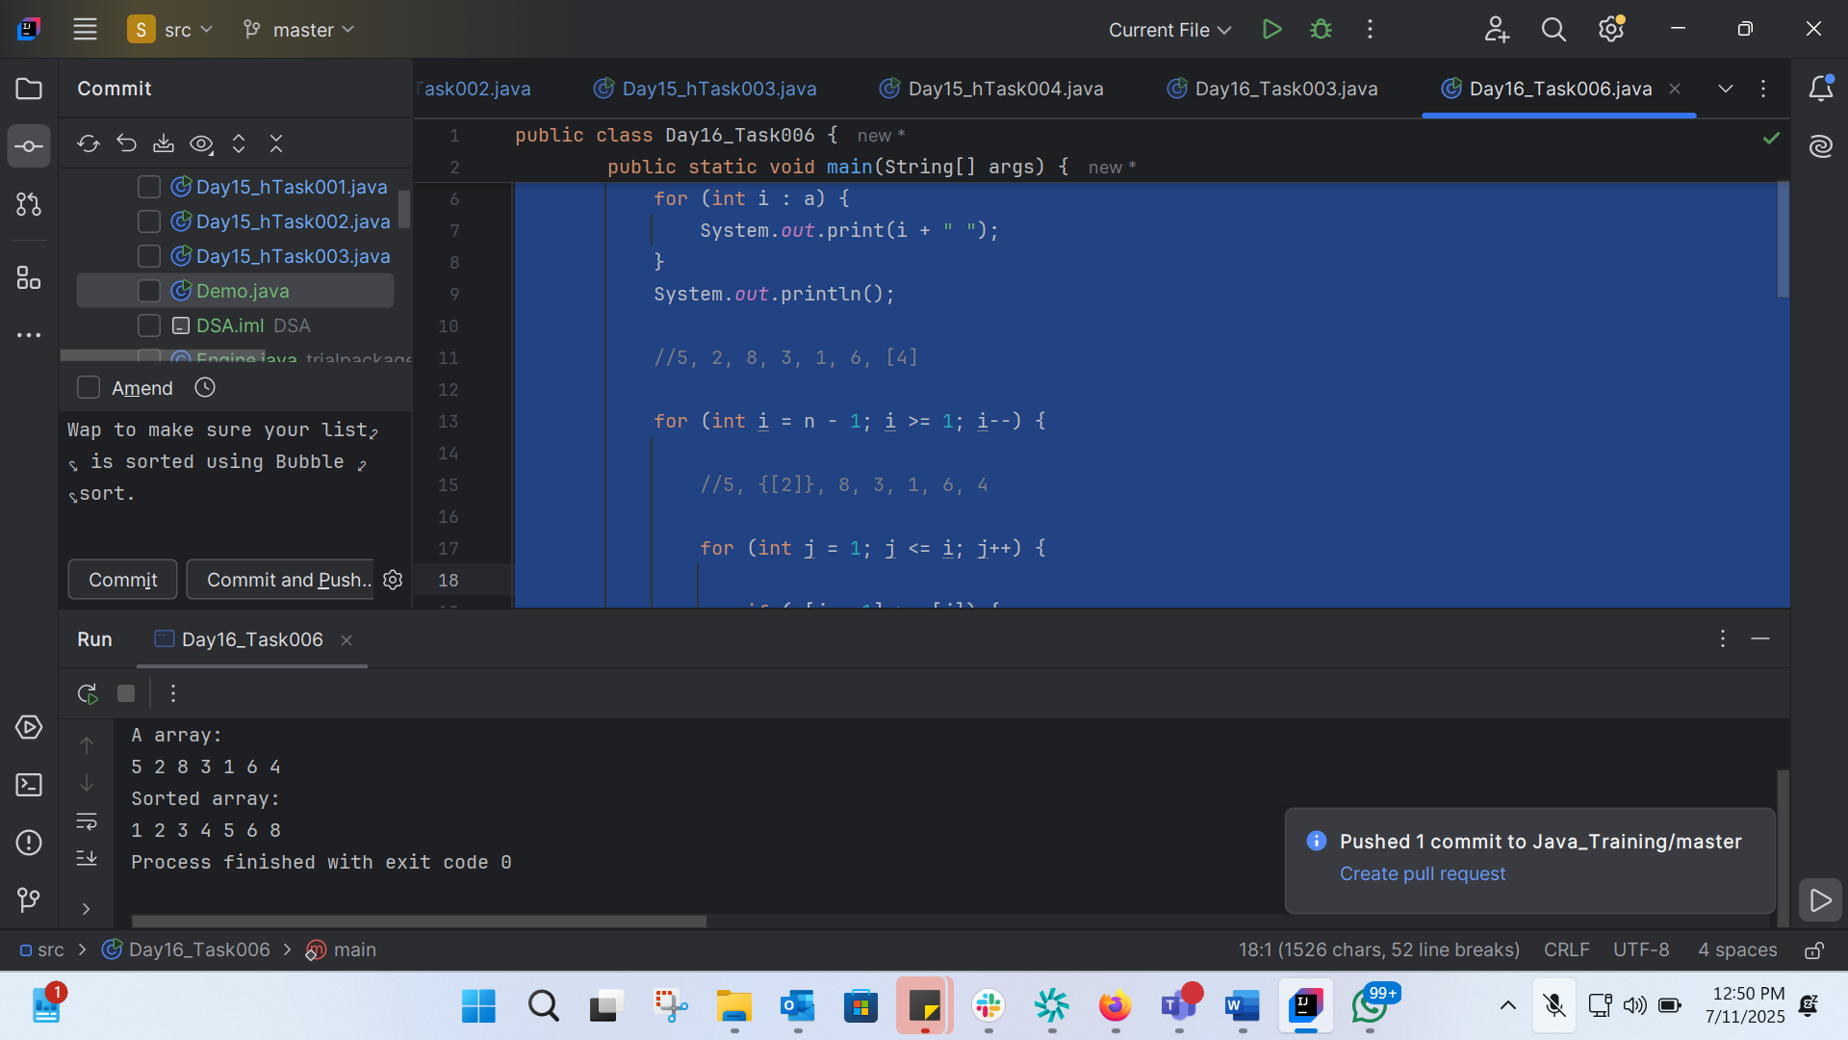
Task 7:
Write an algorithm for the Insertion sort
- Start with 1st element in array
- Iterate through the rest of array, 1 by 1
- Compare each element with the sorted region
- If the current element is smaller than the sorted region shift the larfer element to the right
- Continue and keep the elemtns in the correct position
Task 8:
Pseudo code:
procedure InsertionSort(arr: array of integers)
for i from 1 to length of arr
key = arr[i]
j = i - 1
While j >= 0 and arr[j] > key
arr[j + 1] = arr[j]
j = j - 1
arr[j + 1] = key
end For
end Procedure

Task 9: Wap to make sure your list is sorted using Insertion sort.
public class Day16_Task009 {
public static void main(String[] args) {
int a[] = {5, 2, 8, 3, 1, 6, 4};
int n = a.length;
System.out.println("Original array:");
for (int i = 0; i < n; i++) {
System.out.print(a[i] + " ");
}
System.out.println();
//void insertionSort(int a[], int n) {
//for (int i = 1; i < n; i++) {
//int next = a[i];
//inserted int next = a[i];
//int j;
//
//for (j = i-1; j >= 0 && a[j] > next; j--)
//a[j+1] = a[j];
//
//a[j+1] = next;
//}
//
//}
//5, [2], 8, 3, 1, 6, 4
for (int i = 1; i < n; i++) {
int next = a[i];
int j;
//[{5}], [2], 8, 3, 1, 6, 4
for (j = i - 1; j >= 0 && a[j] > next; j--) {
a[j + 1] = a[j];
}
a[j + 1] = next;
}
System.out.println("Sorted array:");
for (int i = 0; i < n; i++) {
System.out.print(a[i] + " ");
}
}
}

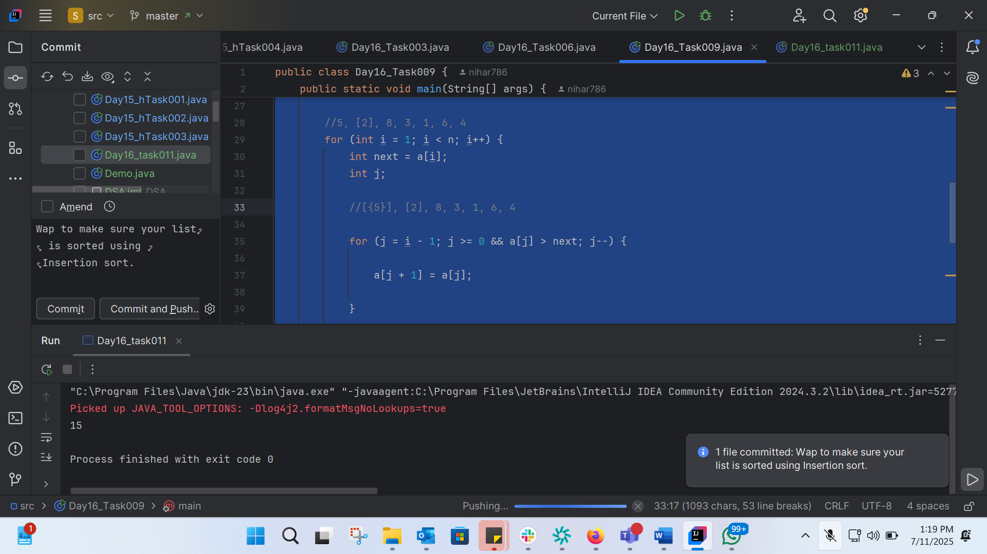
Task 10: ADV and DISADV of bubble sort
Advantages of Bubble Sort:

1. Simple to Implement: Bubble sort is one of the simplest sorting algorithms to understand and implement.
2. Space Efficient: Bubble sort only requires a constant amount of additional memory for variables, making it a space-efficient algorithm.
3. Stable: Bubble sort is a stable sorting algorithm, meaning that equal elements will maintain their original order after sorting.

Disadvantages of Bubble Sort:

1. Poor Performance: Bubble sort has a worst-case and average time complexity of O(n^2), making it inefficient for large datasets.
2. Slow for Large Datasets: Due to its high time complexity, bubble sort is not suitable for large datasets and can be very slow.
3. Not Efficient for Reverse Sorted Arrays: Bubble sort performs poorly on reverse sorted arrays, requiring n*(n-1) comparisons and swaps.
4. Not Suitable for Real-World Applications: Due to its poor performance, bubble sort is not commonly used in real-world applications, especially for large datasets.
5. High Number of Comparisons and Swaps: Bubble sort requires a large number of comparisons and swaps, making it inefficient compared to other sorting algorithms like quicksort or mergesort.

When to Use Bubble Sort:

1. Small Datasets: Bubble sort can be used for small datasets where the simplicity of the algorithm outweighs its performance limitations.
2. Educational Purposes: Bubble sort is often taught in introductory programming courses due to its simplicity and ease of understanding.
3. Nearly Sorted Data: Bubble sort can perform well on nearly sorted data, as it only requires a few passes to sort the array.
Task11:
//public class RecLoop {
//
// public int calc(int n) {
// if (n == 0) return 0;
// return n + calc(n);
// }
//
public class Day16_task011 {
public int calc(int n) {
if (n == 0) return 0;
return n + calc(n - 1);
//return calc -1
}
public static void main(String[] args) {
Day16_task011 rl = new Day16_task011();
System.out.println(rl.calc(5));
}
}

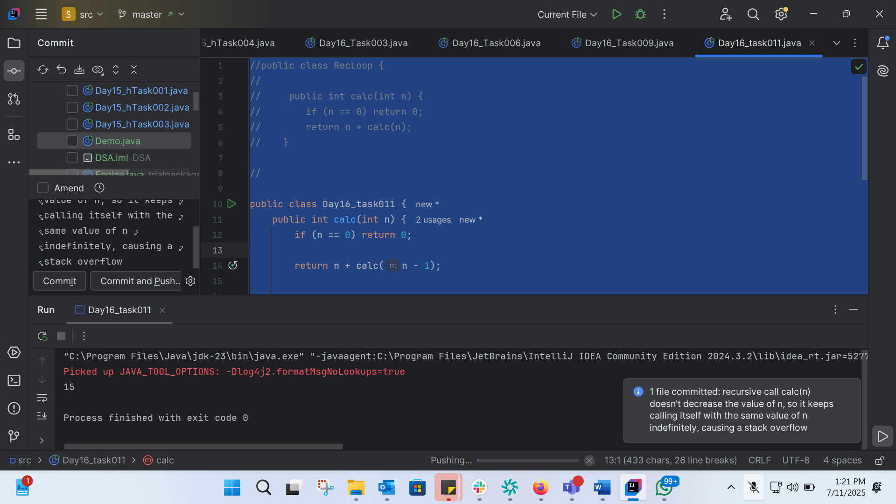
Task 12:
Write an algorithm for the Merge Sort
1. Divide the array into two halves until each half has one element.
2. Merge the two halves by comparing elements and placing them in the correct order.
3. Repeat the merge process until the entire array is sorted.
Task 13:
pseudo code for merge sort,
Procedure MergeSort(arr: array of integers, low: integer, high: integer)
If low < high
mid = (low + high) / 2
MergeSort(arr, low, mid)
MergeSort(arr, mid + 1, high)
Create temporary array temp
i = low, j = mid + 1, k = 0
While i <= mid and j <= high
If arr[i] <= arr[j]
temp[k] = arr[i]
i = i + 1
Else
temp[k] = arr[j]
j = j + 1
End If
k = k + 1
End While
While i <= mid
temp[k] = arr[i]
i = i + 1
k = k + 1
End While
While j <= high
temp[k] = arr[j]
j = j + 1
k = k + 1
End While
For i = low to high
arr[i] = temp[i - low]
End For
End If
End Procedure

Task 14:
code for Merge sort
public class Day16_Task014 {
//initallizing the arreay a
public static void main(String[] args) {
int[] a = {5, 2, 8, 3, 1, 6, 4};
System.out.println("Original array:");
for (int i : a) {
System.out.print(i + " ");
}
System.out.println();
mergeSort(a, 0, a.length - 1);
System.out.println("Sorted array:");
for (int i : a) {
System.out.print(i + " ");
}
}
//void mergeSort(int a[], int low, int high) {
//if (low < high) {
//int mid = (low+high) / 2;
//
//mergeSort(a, low , mid );
//
//mergeSort(a, low , mid );
//mergeSort(a, mid+1, high);
//
//merge(a, low, mid, high);
//}
//}
// [5,2][8,3]//[1,6][4]
//[2,5][3,8]//[1,6][4]
//taking array a and 2 parameters low n high
//here a, 0, length-1
public static void mergeSort(int[] a, int low, int high) {
//5, 2, 8, 3,// 1, 6, 4
//0<6
//0+6/2=3
if (low < high) {
//calc mid pnt of array
int mid = low + (high - low) / 2;
//a,0,3
mergeSort(a, low, mid);
//a,3+1,6
mergeSort(a, mid + 1, high);
merge(a, low, mid, high);
}
}
//Merge Implementation
//int n = high-low+1;
//int* b = new int[n];
//int left=low, right=mid+1, bIdx=0;
//
//while (left <= mid && right <= high) {
//if (a[left] <= a[right])
//b[bIdx++] = a[left++];
//else
//b[bIdx++] = a[right++];
//}
//
//while (left <= mid) b[bIdx++] = a[left++];
//while (right <= high) b[bIdx++] = a[right++];
//
//for (int k = 0; k < n; k++)
//a[low+k] = b[k];
//
//delete[]b;
//}
public static void merge(int[] a, int low, int mid, int high) {
int n = high - low + 1;
int[] b = new int[n];
int left = low, right = mid + 1, bIdx = 0;
while (left <= mid && right <= high) {
if (a[left] <= a[right]) {
b[bIdx++] = a[left++];
} else {
b[bIdx++] = a[right++];
}
}
while (left <= mid) {
b[bIdx++] = a[left++];
}
while (right <= high) {
b[bIdx++] = a[right++];
}
for (int k = 0; k < n; k++) {
a[low + k] = b[k];
}
}
}

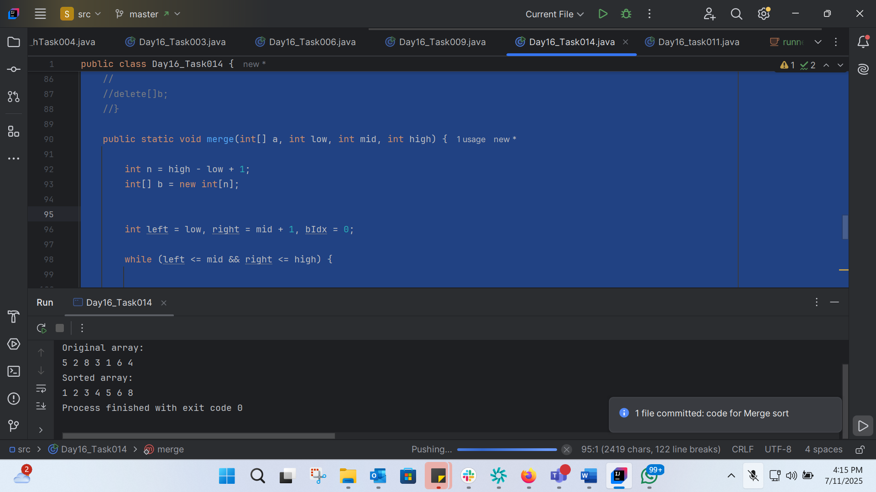
Task 15:
Algo fro quick sort

- Choose a pivort
- Partition
- Recursively sort subarrays
- Combine
Task 16:

Quick sort : implementation
void quickSort(int a[], int low, int high) {
if (low < high) {
int pivotIdx = partition(a, low, high);
quickSort(a, low, pivotIdx-1);
quickSort(a, pivotIdx+1, high);
}
}
Quick sort: Partition
int partition(int a[], int i, int j) {
int p = a[i];
int m = i;
for (int k = i+1; k <= j; k++) {
if (a[k] < p) {
m++;
swap(a[k], a[m]);
}
else {
}
}
swap(a[i], a[m]);
return m;
}
Task 17: Code for Quick sort
public class Day16_Task017 {
public static void quickSort(int[] a, int low, int high) {
//low=0, high = 6
if (low < high) {
//initnally low <high
//so finding the partition index
int pivotIdx = partition(a, low, high);
quickSort(a, low, pivotIdx - 1);
System.out.println("Left index sorted");
quickSort(a, pivotIdx + 1, high);
System.out.println("Right index sorted");
}
}
public static int partition(int[] a, int i, int j) {
//i==0, j==6
int p = a[i]; //[5], 2, 8, 3, 1, 6, 4
int m = i;
for (int k = i + 1; k <= j; k++) { //i=0 so i+1
//a[k]=2<5
if (a[k] < p) {
m++;
// Swap a[k] and a[m]
int temp = a[k];
a[k] = a[m];
a[m] = temp;
}
}
// Swap a[i] and a[m]
int temp = a[i];
a[i] = a[m];
a[m] = temp;
return m;
}
public static void printArray(int[] a) {
for (int i : a) {
System.out.print(i + " ");
}
System.out.println();
}
public static void main(String[] args) {
int[] a = {5, 2, 8, 3, 1, 6, 4};
System.out.println("Original array:");
printArray(a);
quickSort(a, 0, a.length - 1);
System.out.println("Sorted array:");
printArray(a);
}
}

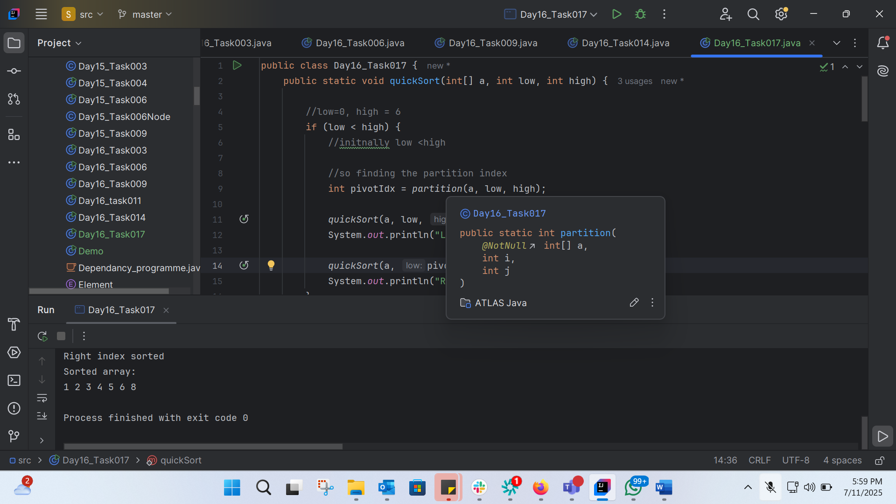
public class Day16_Task017 {
public static void quickSort(int[] a, int low, int high) {
//low=0, high = 6
if (low < high) {
//initnally low <high
//so finding the partition index
int pivotIdx = partition(a, low, high);
quickSort(a, low, pivotIdx - 1);
System.out.println("Left index sorted");
quickSort(a, pivotIdx + 1, high);
System.out.println("Right index sorted");
}
}
public static int partition(int[] a, int i, int j) {
//i==0, j==6
int p = a[i]; //[5], 2, 8, 3, 1, 6, 4
int m = i;
for (int k = i + 1; k <= j; k++) { //i=0 so i+1
//a[k]=2<5
if (a[k] < p) {
m++;
// Swap a[k] and a[m]
int temp = a[k];
a[k] = a[m];
a[m] = temp;
}
}
// Swap a[i] and a[m]
int temp = a[i];
a[i] = a[m];
a[m] = temp;
return m;
}
public static void printArray(int[] a) {
for (int i : a) {
System.out.print(i + " ");
}
System.out.println();
}
public static void main(String[] args) {
int[] a = {5, 2, 8, 3, 1, 6, 4};
System.out.println("Original array:");
printArray(a);
quickSort(a, 0, a.length - 1);
System.out.println("Sorted array:");
printArray(a);
}
}

Add ons:

Binary Tree
A Binary Tree is a data structure in which each node has at most two children (i.e., left child and right child). This structure allows for efficient traversal and manipulation of nodes.
Structure:
- Each node has a value and references to its left and right children.
- The tree can be traversed in various ways (e.g., inorder, preorder, postorder).
Operations:
- Insertion: Nodes can be inserted at any position in the tree.
- Deletion: Nodes can be deleted from any position in the tree.
- Traversal: The tree can be traversed in various ways.

Binary Search Tree (BST)
A Binary Search Tree is a special type of Binary Tree where each node has a comparable value, and the left subtree of a node contains only values less than the node's value, while the right subtree contains only values greater than the node's value.
Structure:
- Each node has a value and references to its left and right children.
- The tree is ordered such that for any node:
- All values in the left subtree are less than the node's value.
- All values in the right subtree are greater than the node's value.
Operations:
- Insertion: Nodes are inserted in a way that maintains the BST property.
- Deletion: Nodes are deleted in a way that maintains the BST property.
- Search: The tree can be searched efficiently using the BST property.
Key differences:
- Structure: While both Binary Trees and BSTs have a similar structure, BSTs have an additional ordering property that makes them useful for efficient searching.
- Operations: BSTs have more restrictive insertion and deletion operations to maintain the ordering property, whereas Binary Trees do not have such restrictions.
- Search: BSTs allow for efficient searching due to the ordering property, whereas Binary Trees do not have a built-in search mechanism.
To illustrate the difference, consider the following examples:
- A Binary Tree can be:
1
/ \
3 2
/ \
4 5
- A Binary Search Tree (BST) would be:
4
/ \
2 5
/ \
1 3
In the BST example, the ordering property is maintained, making it suitable for efficient searching.

Question 2 : In sorted array why do you think binary search tree is best than linear search.. Can you ecplain plz
Binary Search is a more efficient search algorithm than Linear Search for sorted arrays due to its logarithmic time complexity. This makes it a better choice for large datasets.
Question 3: Difference between static and dynamic arrays.. Plz list them
- Static arrays:
- Have a fixed size that cannot be changed.
- Are more memory-efficient if the size is known in advance.
- Are faster than dynamic arrays because they don't have the overhead of dynamic memory allocation.
- Dynamic arrays (ArrayList):
- Have a dynamic size that can be changed.
- Are more flexible and convenient to use when the size of the array is not known in advance.
- May have performance overhead due to dynamic memory allocation.

When to use static arrays:
- When the size of the array is known in advance and will not change.
- When memory efficiency is a concern.

When to use dynamic arrays (ArrayList):
- When the size of the array is not known in advance or may change dynamically.
- When flexibility and convenience are more important than performance.

Question 4: In BFS, DFS which one is more preferred in terms of shortest path for the unweighted graphs.
Note:
BFS explores nodes in increasing distance order from the source, ensuring shortest paths are found first.

For unweighted graphs, Breadth-First Search (BFS) is generally preferred over Depth-First Search (DFS) for finding the shortest path.
Why BFS is preferred:
1. Shortest path guarantee: BFS explores nodes in increasing distance order from the source, ensuring that the shortest path is found first.
2. Level-by-level exploration: BFS explores all nodes at a given distance from the source before moving on to nodes at a greater distance.

Why DFS is not preferred:
1. No shortest path guarantee: DFS does not guarantee finding the shortest path first, as it explores nodes in a depth-first manner.
2. May get stuck in long paths: DFS may get stuck in long paths that are not the shortest path to the target node.

Question 5:
implement a stack using an array
public class Day16_Stack_using_array {
private int[] array;
private int top;
private int capacity;
public Stack(int capacity) {
this.capacity = capacity;
this.array = new int[capacity];
this.top = -1;
}
// Push an element onto the stack
public void push(int element) {
if (isFull()) {
System.out.println("Stack Overflow: Cannot push element " + element);
return;
}
array[++top] = element;
}
// Pop an element from the stack
public int pop() {
if (isEmpty()) {
System.out.println("Stack Underflow: Cannot pop element");
return -1; // or throw an exception
}
return array[top--];
}
// Get the top element of the stack
public int peek() {
if (isEmpty()) {
System.out.println("Stack is empty");
return -1; // or throw an exception
}
return array[top];
}
// Check if the stack is empty
public boolean isEmpty() {
return top == -1;
}
// Check if the stack is full
public boolean isFull() {
return top == capacity - 1;
}
// Print the stack elements
public void printStack() {
if (isEmpty()) {
System.out.println("Stack is empty");
return;
}
System.out.print("Stack elements: ");
for (int i = 0; i <= top; i++) {
System.out.print(array[i] + " ");
}
System.out.println();
}
public static void main(String[] args) {
Day16_Stack_using_array stack = new Day16_Stack_using_array(5);
stack.push(1);
stack.push(2);
stack.push(3);
stack.printStack(); // Output: Stack elements: 1 2 3
System.out.println("Popped element: " + stack.pop()); // Output: Popped element: 3
stack.printStack(); // Output: Stack elements: 1 2
System.out.println("Top element: " + stack.peek()); // Output: Top element: 2
}
}

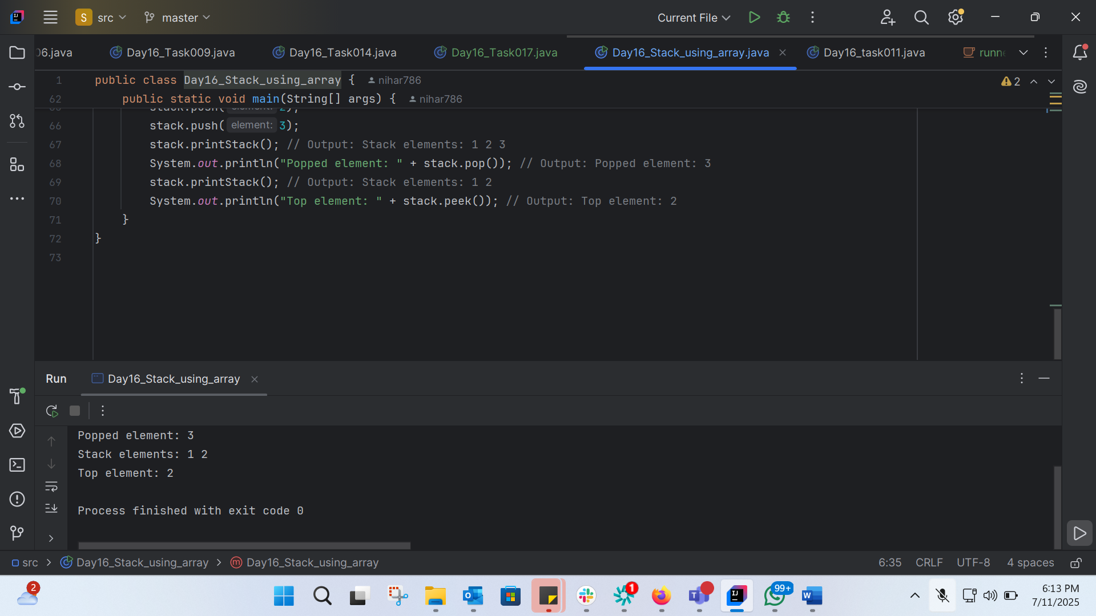

Wap to find the factorial of a number
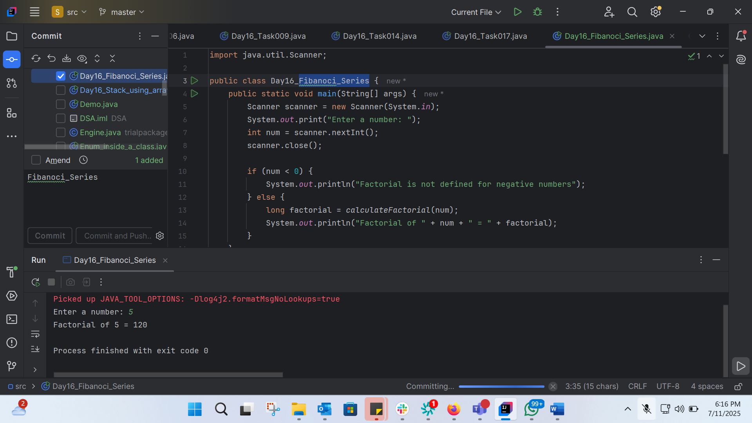
import java.util.Scanner;
public class Day16_Fibanoci_Series {
public static void main(String[] args) {
Scanner scanner = new Scanner(System.in);
System.out.print("Enter a number: ");
int num = scanner.nextInt();
scanner.close();
if (num < 0) {
System.out.println("Factorial is not defined for negative numbers");
} else {
long factorial = calculateFactorial(num);
System.out.println("Factorial of " + num + " = " + factorial);
}
}
public static long calculateFactorial(int num) {
long factorial = 1;
for (int i = 1; i <= num; i++) {
factorial *= i;
}
return factorial;
}
}

Wap to find the Fibonacci series of a number
